CMP-5012B Software Engineering 1

Group Project Stage 1 - Report

Jack Sayer (100168100), Ben Wood (), Rob Barton (), Cameron Bird() and NAHIMul Islam()

# 1. Project description

## 1.1 Main objective and overview

##### **Scenario: Health Tracker**

# **1. OVERVIEW**

A big insurance company is at the forefront of the UK personal health insurance market. It wants to develop new products which leverage both emerging technology and societal trends and in particular wants to explore the idea of a “health tracker” application. The Health Tracker aims to help inform users of basic health information as well as enable them to track their diet and fitness regime with simple goals and trending over time to see results. Initially this application is not tied to an insurance product offered by the insurance company but should support integration at a later stage if successful. The insurance company wants you to develop a solution which enables this idea to be explored as a business experiment.

# **2. SOLUTION DESCRIPTION**

The “health tracker” solution must support the creation of a basic user profile which enables a user to record key information about them. This includes physical details such as height, weight and other information required to generate a comparison of user to a healthy norm.

In addition, basic information will need to be captured including real name, a user name (which can be selected by the user but must be unique) and an e-mail address which the system should validate whether it is in a valid format. The system will use the captured e-mail address to enable e-mail communications. If this initial business experiment is successful the e-mail communication component may be augmented or replaced with instant messaging or other rapid communication mechanisms such as those enabled through social network platforms. The social network capability may be extended at a later date to enable sharing of goals and membership of groups.

Three central capabilities are required by the solution. The capability to:

1. Record on-going lifestyle details such as exercise taken and diet
2. Ability to set goals
3. And view a history of this information

The basic workflow of the health tracker solution is outlined below:

1. **User registration**
2. Enter a user name
   * 1. If user name already exists in the system then the user is prompted for a new user name
3. Capture the users real name
4. Capture their email address and validate it is in a correct format
   * 1. If validation fails prompt for a correction before allowing registration to proceed
5. Collect additional personal information required to provide initial health overview, e.g. ideal weight, BMI, …
   * 1. Height and weight are key factors but the solution may require additional information identified by the development teams to support their health analytics / algorithm
6. If the information collected suggests a deviation of the norm provide appropriate feedback
   * 1. This could include the capture of some initial goal details, such as a target weight

1. **In use the solution provides two user data capture paths, exercise and diet**
2. Exercise capture supports the selection of a type of exercise and the duration and/or distance for a specific exercise session
   * 1. Type of exercise is a defined set of activities
3. Diet capture supports the selection of food and drink together with a value and the meal
   * 1. Food and drink types from a list with the ability of the end user to add custom items to the list
     2. The value captured is a calorific count
     3. The meal is a defined set of meal types
4. **Goal Capture and Reporting**
5. Goals are captured, recording a target such as a weight and a date
   * 1. Optionally the creation of more complex goals, such as running a set distance under a set time
     2. If a goal is already met, advice the user and suggest a new goal
6. When the solution starts or is running using the system time it checks if any goals have exceeded target dates
   * 1. A message is displayed stating goal met or not and asks if a new goal is to be set
     2. New goal set from C.1 step
7. Regular capture of weight is required to identify if a weight target has been met
   * 1. Optionally this may be user configurable
8. **User Groups**
9. Users can create and join groups to share progress towards targets
   * 1. Groups can be created, each group will have a unique group name
     2. Group details can be shared via an e-mail using the registered users e-mail address
10. Opt in and opt out
    * 1. Users can join a group from using details held within the email, this maybe a code or web link within the e-mail content
      2. Users can select a group they are a member of and delete their membership
11. Group goals and achievements
    * 1. Goals are distributed via e-mail and if acceptable the solution accepts a code or link to create a local goal from the details
      2. Meeting a goal generates an e-mail to the group

## 1.2 Analysis of similar systems

### MyFitnessPal

###### Features

* Goals
  + Tracks starting weight, current weight and goal weight
    - Calculates daily calorie goal by weekly goal and activity level
  + Customisable macro goals
    - Percentages of carbs, protein and fat
* Calories tracker
  + In a goal - food + exercise = remaining format
  + Allows you to add foods to meals
    - Breakfast, lunch, dinner, snacks
      * These can be manually inputted or from a list of already inputted foods
      * Can be scanned from product barcode
  + Allows you to add exercise
    - Calculates calories from activity type, time and intensity inputted
  + Shows a pie chart of which meals your calories come from, and the macros from all the food you have eaten that day
  + List of the foods highest in fat you’ve eaten
  + List of foods highest in protein you’ve eaten
  + Ability to see previous days calories
* Progress graphs of weight
  + Shows actual weight against goals
* Challenges
* Articles
  + Information on specific foods and exercises
* Friends
  + Notifications when they do exercise / lose weight etc
  + Ability to see their food intake and exercise
  + See how much weight they’ve lost / gained in total

###### Missing/Bad features

* Graph of actual calorie intake vs goal
* Graph of calorie intake vs weight

### Fitocracy

###### Features

* List of individual exercises & combined workouts
  + Video demonstrations
  + Can set exercise parameters e.g. reps, weight, distance, time etc.
* Social feed
* Metric vs Imperial measurements
* No weight/fitness goal system
  + Only tracks exercise by points
* Too many damn popups
* User creation
  + Email, password, name
  + Weight, height, age, gender
* Can connect with other users through groups
* Achievements based on exercise points & user interaction

###### Missing/Bad features

* Custom weight/fitness goals
  + Only tracks fitness by points from exercise
  + Only goals are leveling up
* No tracking of food & drink intake

### FatSecret

###### Features

* User creation
  + Name, weight, height, exercise levels
  + Define goals; weight loss/gain, fitness levels (run distances, weight lifting etc)
  + Generates daily caloric intake based on information entered
* Diet tracking
  + Enter foods and drink for each meal of the day plus snacks
  + Database of food with nutritional info provided
  + Can add your own foods if they are not in the database
  + Can create whole meals to avoid entering individual food items
  + Has caloric information from popular chains and restaurants
  + Tracks how close you are to caloric and nutrient goals as you enter the food you've eaten
  + Only seems to care about macronutrients(fat, protein, carbs) and not micronutrients
* Exercising tracking
  + Similar to the food tracker but with exercise
  + Deducts the calories burned during each exercise from your caloric intake for the day
  + Loads of preset exercises e.g. different run distances at different speeds
* Weight tracking
  + Graphs users weight over time
  + When you weigh in you can provide tips and journal entries for other users to read
  + Limited wight information, only a single line graph
* Journal
  + Allows journal entries for other people to read, similar to a blog. I assume it is for advice and motivation reasons.
  + Journal editor is bad - just plain text with no formatting options at all.
  + The journal entries go to a feed that followers can see. There is no curation or moderation at all so it seems very spammy and not useful at all.
  + Facebook style comments on journal entries allow for social interaction
* Dashboard
  + Plain, uninteresting dashboard with the focus being on the activity feed of others with links to the various features.
  + Works well but is not pleasant to look at.
  + The feed can be filtered (all users, friends, groups, me)
  + Overall UI is not clean nor simple, there is lots of little text everywhere and it is not immediately obvious how to navigate the site.
* Other features
  + Recipes: Allows users to upload recipes and other uses can comment and rate them. Recipes have a button that allows the user to add it to the food diary with all caloric and nutritional information.
  + Challenges: User defines a challenge or chooses a preset one. Things like lose x amount of weight in x amount of dates. The rules of the challenge are clearly defined. They have a community feel to them as everyone can post updates of how they are doing and provide tips and encouragement.
  + Messaging system
  + Profile customisation
  + Forums

###### Missing/Bad features

* No social media integration
* No responsive design

### Runkeeper

###### Features

* Login/ registration:
  + Straight to profile setup - profile picture(optional) from file upload
  + Personal info(optional) - Full name, location, gender, date of birth.
  + Weight - select Ibs or kg.
    - Mostly simple, easy to view and enter.
* FitnessFeed
  + Feed showing friends activity - comments/status.
  + Body measurements: add new weight, view historical changes. - breaks after submitting, blank page.
  + Can find other users by name:
  + Set location
  + Connect to mobile apps.
* Main dashboard called ‘my activity total’
  + Main page - add goals, lists recent activities – can be hidden.
  + Same link to the feed and can add comments to.
  + Small graphics of the information on left panel but shown more largely.
  + Simple to view and not cluttered.
* Add new goal button –
  + pop up box gives a list of suggested goals and type such as running or walking, etc.
  + Distance and date to achieve by.
  + Can only select date in the future and gives remaining days to complete goal.  Under goal green button to find race of distance selected.
  + This finds races between dates that the user selects.
    - Does not work every time. Finds races in other countries such as France, although the user can select the location.
* Reports
  + View progress between a duration such as last 30 days to 1 year.
  + Can only view distance graph.
  + Other graphics such as calories burned are locked behind a monthly payment plan of $9.99 / month **-** which is expensive compared to other trackers.
  + Suggested apps for categories, such as sleep apps, activity tracking.
* Training
  + Create training plan - not accessible unless upgrade to payment plan.
  + Create free training plan if using mobile app.
  + Gives few free plans - such as a 5k run.
* Activities
  + Lists activities created on mobile app.
  + Track using gps
  + Can’t create on website.
* Friends
  + Add friends
  + Set location
  + Find user by name
  + See how friends are doing.
* Routes
  + Create an exercise route - see map, compare, calculate distance.

###### Missing/Bad Features

* Account settings
* Search function
* Log activity with map, date, bpm, calories
* Shows map of distance run, start and finish. Calculate distance, time, average pace and calories burnt.
* Some errors on page when submitting forms.
* Payment plan of 9.99/month
* Design.
  + Simplistic base colours scheme of white and blue.
  + Dashboard layout centred with an easy access navigation to different information on USER.
  + Main navigation bar to main pages. Left panel includes total activities, distance, calories and weight.  Body measurements are only viewable to the user.
  + Also location. Small icon graphics for each navigation button – clear and legible text.
  + Inclusion of a few colours for buttons, such as a lime green.
  + Easy navigation and layout of sections not covered in adverts and pop ups.
  + Pages not cluttered and design mostly consistent.
  + Looks amateurish if paying $9.99/month, otherwise decent free website.
  + Good vector graphical images.

### Strava

###### Features

* Account creation
  + Ability to sign up with a Facebook account, Google account or with your email.
    - Must provide a first name, last name, email and password.
  + User form prompt asking for a picture, names, date of birth and gender.
    - Suggestion to connect with your friends imported from Facebook.
* Dashboard
  + Activity Feed
    - Profile section showing how many you follow, how many followers you have, your number of activities and your most recent activity.
    - Running, Cycling, Swimming data for a given period (this week and this year) with the option to ‘manage goals’.
    - Shows your activities as posts in timeline.
      * Posts can be given ‘kudos’ and be commented on.
  + My Segments
    - Segments are sections of roads/climbs/trail you can create yourself or ‘star’ those created by other users.
    - You can see how you perform in these segments over time, monitoring how you improve and compare with other athletes that complete the segment (friends, local athletes and pros).
    - Features a leader board system to see where you rank.
  + My Routes
    - Allows users to create their own custom routes.
      * Draw on a map, selecting whether it’s for running or cycling. Gives the distance, elevation gain and est. time to complete.
    - You can view your routes with the ability to:
      * Print them out, export them to specific file types, edit them, duplicate them and share the route through social media (Facebook, Twitter or email).
  + My Goals (premium)
    - Allows you to set weekly progress goals of times or distance and track how you progress towards the targets.
    - Allows you to set segment goals to try and accomplish along with a deadline by which you wish to complete this goal.
* Training
  + Training Log
    - Provides different view for you activities (distance, time and elevation gain), plotting your activities on a weekly timeline.
    - Displays each week as a separate timeline in the view and shows you each month at a time.
    - Tags different types of run (races, long runs and workouts) for quick association with what each activity was.
    - Hovering over each activity expands to provide further information.
  + Training Calendar
    - Displays how many hours of activities you have done for each month and allows you to see a calendar view of all activities.
  + My activities
    - Gives a table of all of the activities entered with the option to search and filter by sport.
      * Each activity row provides the sport, date, title, time, distance, elevation and the option to edit, delete or share this activity.
  + Training videos and training plans (premium) can be accessed to follow set routines and reach specific goals.
* Explore
  + You can search for other users segments to compete against them and make it onto the lead boards.
  + Ability to search for ‘atheletes’ (users) and follow them. Seeing what achievements they have reached, photos they have posted and their activities. You can also compare your data side-by-side with theirs to see how you match up.
  + You can find and join clubs in your local area, giving you access to weekly group leader boards and club posts.
  + You can find races to compete in, searching by the distance and their location.
* Challenges (premium)
  + Join in with challenges to make it on the leader boards and earn digital badges for your profile.
* Upload activities from a variety of fitness trackers, file or other services (Nike+, MapMyFitness, RunKeeper, Endomondo & Runtastic).
* Add manual entry; inputting distance (with unit selection), duration, type of sport, date & time, title, tags and a description.
* Notifications to inform you of friends updates.

###### Missing/Bad features

* No food log of any kind, so unable to track calories consumed vs calories burned.
* No weight goals, application aimed more at exercise ability to monitor fitness over user’s metrics.
* Several useful features are locked behind a premium paywall, limiting how far users can take the application.
* Application seem very mobile app oriented, with frequent prompts to use the mobile app.

## 1.3 Feature matrix from similar systems

|  |  |  |  |  |  |
| --- | --- | --- | --- | --- | --- |
| **Website** | MyFitnessPal | Fitocracy | FatSecret | Runkeeper | Strava |
| **Goals** | ✓ | ✓ |  | ✓ | ✓ |
| **Weight Tracking** | ✓ |  | ✓ |  |  |
| **Meal Tracking** | ✓ |  | ✓ |  |  |
| **Exercise Tracking** | ✓ | ✓ | ✓ | ✓ | ✓ |
| **Progress Graphs** | ✓ |  | ✓ |  | ✓ |
| **Challenges** | ✓ |  | ✓ |  | ✓ |
| **Informative Articles (blog/recipes)** | ✓ |  | ✓ |  |  |
| **Social Interaction (Friends/Feed)** | ✓ | ✓ | ✓ | ✓ | ✓ |
| **User Profile** | ✓ |  | ✓ | ✓ | ✓ |
| **Dashboard** | ✓ |  | ✓ | ✓ | ✓ |
| **User Groups** |  | ✓ |  |  | ✓ |
| **Forums** |  |  | ✓ |  |  |
| **Leader boards** | ✓ |  |  |  | ✓ |

## 1.4 MoSCoW

|  |  |  |  |  |
| --- | --- | --- | --- | --- |
| **Requirement** | **Must** | **Should** | **Could** | **Wont** |
| Record exercise to calculate calories burned | ✓ |  |  |  |
| Adding custom meals into the food tracker |  | ✓ |  |  |
| View food intake and exercise of a friend on the system |  |  | ✓ |  |
| Add friends |  |  | ✓ |  |
| Comment on a friends profile |  |  | ✓ |  |
| Like a friends comment |  |  | ✓ |  |
| View graphs |  |  | ✓ |  |
| Estimate weight loss |  |  | ✓ |  |
| Add personal information (name, age, weight) |  | ✓ |  |  |
| Creating a health plan |  |  | ✓ |  |
| Find recipes |  |  | ✓ |  |
| Track micro and macronutrients |  | ✓ |  |  |
| Record weight and calculating BMI | ✓ |  |  |  |
| Record food intake and see calories consumed | ✓ |  |  |  |
| Record water intake and compare with recommended amounts |  |  | ✓ |  |
| Record run times/distance to improve speed |  | ✓ |  |  |
| Record personal bests | ✓ |  |  |  |

# 2. User stories and use case

## 2.1 User stories (with associated feature descriptions)

|  |  |  |
| --- | --- | --- |
| **Recording weight & calculating BMI** | 1 | MUST |
| **As an** individual trying to lose weight | | |
| **I want to** record my weight and be shown my BMI | | |
| **So that I can** achieve my goal of losing weight | | |

* 1. User input of weight and height
  2. Calculation of BMI
  3. Compare value against BMI scale/chart

|  |  |  |
| --- | --- | --- |
| **Recording food intake and see calories consumed** | 2 | MUST |
| **As an** individual adhering to a diet plan | | |
| **I want to** be able to record all of the food and meals I eat in a day | | |
| **So that I can** see the number of calories I am consuming and check if I am eating too little or too much | | |

* 1. User input of food consumed
  2. Check food database to calculate calories
  3. Return value

|  |  |  |
| --- | --- | --- |
| **Recording water intake and compare with recommended quantities** | 3 | COULD |
| **As an** individual looking to improve their wellbeing | | |
| **I want to** be able to track the amount of water that I am consuming each day | | |
| **So that I can** see the if I am reaching my target/the daily recommended amount | | |

* 1. User decides whether to have a custom target or the recommended target
  2. User inputs when they drink and how much they drank
  3. Inform user when target has been reached
  4. Display on a graph to see trends over time

|  |  |  |
| --- | --- | --- |
| **Recording run time/distance to improve my speed** | 4 | SHOULD |
| **As an** individual with a keen interest in running | | |
| **I want to** be able to record the length of time it takes me to run a set distance | | |
| **So that I can** see the if I am improving and getting faster | | |

* 1. User input of run distance and the time taken
  2. Calculation of the pace for that run
  3. Comparison with past performances

|  |  |  |
| --- | --- | --- |
| **Recording personal bests for the gym** | 5 | COULD |
| **As an** individual with a passion for the gym | | |
| **I want to** be able to input my personal bests for different pieces of equipment | | |
| **So that I can** see I am improving my physical ability and making progress towards any targets | | |

* 1. User input of weight lifted/number of reps on a piece of equipment
  2. Comparison against previously achieved values

|  |  |  |
| --- | --- | --- |
| **Recording exercise to see calories burned** | 6 | MUST |
| **As an** individual that exercises | | |
| **I want to** be able to input my activities and exercise | | |
| **So that I can** see the amount of calories I have burned exercising and know how many calories I need to consume or burn to reach my goals | | |

* 1. User selects an activity from a list of options
  2. User input of duration and intensity
  3. Calculation of the calories burned

|  |  |  |
| --- | --- | --- |
| **Adding custom meals into the food tracker** | 7 | SHOULD |
| **As an** individual that makes homemade meals | | |
| **I want to** be able to create custom meals with nutritional information | | |
| **So that I can** select these meals in the future instead of manually inputting it each time | | |

* 1. User input of meal name, items and quantities of each item that make up the meal
  2. Store custom meal in the database

|  |  |  |
| --- | --- | --- |
| **Viewing food intake and exercise for a friend** | 8 | COULD |
| **As an** individual that is getting fit with a friend | | |
| **I want to** be able to see my friends exercise and food intake | | |
| **So that I can** motivate my friend and work together to improve ourselves | | |

* 1. Search for a friend’s profile
  2. View their exercise and food intake information

|  |  |  |
| --- | --- | --- |
| **Adding friends** | 9 | COULD |
| **As an** individual who want to keep in touch with friends | | |
| **I want to** be able to add friends | | |
| **So that I can** keep up-to-date with their progress and keep in contact | | |

* 1. Search for friends
  2. Request to be ‘friends’
  3. View a friend’s profile

|  |  |  |
| --- | --- | --- |
| **Comment on a friend’s post** | 10 | COULD |
| **As an** individual who wants to communicate with friends | | |
| **I want to** be able to comment on their posts (activities they have done) | | |
| **So that I can** give them encouragement and communicate with them | | |

* 1. View a friend’s profile
  2. Enter a comment for a specific post
  3. Submit the comment

|  |  |  |
| --- | --- | --- |
| **Like a friend’s post** | 11 | COULD |
| **As an** individual who wants to show my friend’s support | | |
| **I want to** be able to ‘like’ a friend’s post | | |
| **So that I can** see the if I am improving and getting faster | | |

* 1. View a friend’s profile
  2. View a friend’s post
  3. Chose the like option on the post

|  |  |  |
| --- | --- | --- |
| **View data graphs** | 12 | COULD |
| **As an** individual who wants to see how they are progressing | | |
| **I want to** be able to view graphs of my progress | | |
| **So that I can** see how I am progressing over time | | |

* 1. Select what the user wants to view a graph of
  2. Process the data to construct the graph
  3. Display a graph including past data

|  |  |  |
| --- | --- | --- |
| **Estimate weight loss** | 13 | COULD |
| **As an** individual who wants to see the possible amount of weight I can lose | | |
| **I want to** be able to view possible weight loss if I stick to target calories | | |
| **So that I can** keep track and stay motivated | | |

* 1. View projection information as a graph over time
  2. Select how much weight you want to lose – estimate how long it takes
  3. Select the time you have to lose weight – estimate

|  |  |  |
| --- | --- | --- |
| **Edit personal information** | 14 | SHOULD |
| **As an** individual who has an account on the website | | |
| **I want to** be able to change the information stored about me | | |
| **So that I can** keep it up-to-date and personal to me | | |

* 1. View personal profile settings
  2. Change each data field stored for your profile
  3. Save changes to the database

|  |  |  |
| --- | --- | --- |
| **Create a timetable/plan** | 15 | COULD |
| **As an** individual who wants to keep a routine | | |
| **I want to** be able to create a routine timetable to follow and plan my days | | |
| **So that I can** easily follow and keep up-to-date with my weight-loss plan | | |

* 1. Choose which activities to do and when to do them
  2. Choose what meals to eat and when to have them
  3. Display the calories burned/calories consumed for each day
  4. Store the timetable

|  |  |  |
| --- | --- | --- |
| **Finding recipes** | 16 | COULD |
| **As an** individual who wants to learn how to cook healthily | | |
| **I want to** be able to find recipes complete with their nutritional information | | |
| **So that I can** eat healthy meals and monitor the nutrients I am consuming | | |

* 1. Search for recipes by name/ingredients/calories
  2. Return a list of public recipes (meals) that fit those parameters

|  |  |  |
| --- | --- | --- |
| **Tracking macronutrients** | 17 | SHOULD |
| **As an** individual who is a long-time fitness enthusiast | | |
| **I want to** be able to record and monitor my macronutrients for the food I consume | | |
| **So that I can** ensure I am maximising my muscle gains from exercise | | |

* 1. Input of food consumed
  2. Query the database to find food information
  3. Display the nutrient breakdown for the food
  4. Compare the data with the amount needed to reach your goals

## 2.2 Use case

|  |  |  |
| --- | --- | --- |
| **USE CASE NAME** | **User account creation** | |
| **Goal in Context** | To create a new user account for the website, with the user submitting their details and the account information being stored in the database. | |
| **Scope & Level** | Overall system. | |
| **Preconditions** | Web Page is open. User does not already have an account. User has a valid email address. | |
| **Success End Condition** | A new user account has been created. User presented with their dashboard. | |
| **Failed End Condition** | A new user account is not created. | |
| **Primary Actor** | User. | |
| **Trigger** | User selects the ‘sign up’ button. | |
| **SUCCESS SCENARIO** | **Step** | **Action** |
|  | 1 | The register webpage loads up, displaying the required details as a form input. |
|  | 2 | Actor fills out the form details (username, email, firstname, surname, date of birth, current height, current weight & password). |
|  | 3 | Actor selects the submit/register button. |
|  | 4 | System runs checks to determine if the username and email address are valid. |
|  | 5 | System stores the information in the database. |
|  | 6 | System sends the user an email to confirm the account has been created. |
|  | 7 | System presents the actor with their personal dashboard web page. |
| **ALTERNATIVE SCENARIO** | **Step** | **Branching action** |
|  | 3a | The user already has an account. System notifies the user and asks if they wish to recover the account. |
|  | 3b | The username has already been used. System notifies the user and prompts them to choose a different username. |
|  | 3c | The email entered is invalid (does not match an email format). System notifies the user and prompts them to use a valid email address. |
| **RELATED INFORMATION** | | |
| **Priority** | Top priority. | |
| **Performance Target** | - | |
| **Frequency** | Moderate. | |
| **Subordinate Use Cases** | - | |
| **Channel to Primary Actor** | User Interface (web page). | |
| **Secondary Actors** | - | |
| **Channel to Secondary Actors** | - | |
| **OPEN ISSUES** | If database is not online it may not be caught that a user account has not been created. | |
| **SCHEDULE** | Due date is version 1.0 release. | |
| **AUTHOR** | Jack Sayer - 28.02.18 | |

# 3. Object Orient Analysis (OOA)

We performed a natural language analysis on the project specification.

Finding all the nouns we decided whether they were important to the implementation and then whether they would be a class or attributes:

|  |  |  |  |  |  |
| --- | --- | --- | --- | --- | --- |
| User profile | Physical details | Height | Weight | **User** | Real name |
| Username | Email Address | Email communication | Instant messaging | Social Network | **Exercise** |
| Diet | **Goal** | History | Personal Information | Health Overview | Health |
| Duration | Distance | **Session** | **Activity** | **Food** | Drink |
| **Meal** | Calorie count | Meal type | **Target** | Date | Time |
| Target date | Message | Weight target | **Groups** | Group name | Membership |
| **Achievements** |  |  |  |  |  |

Key:

|  |  |
| --- | --- |
| **Class** | Attribute |

We then looked at all the verbs to find relationships between classes.

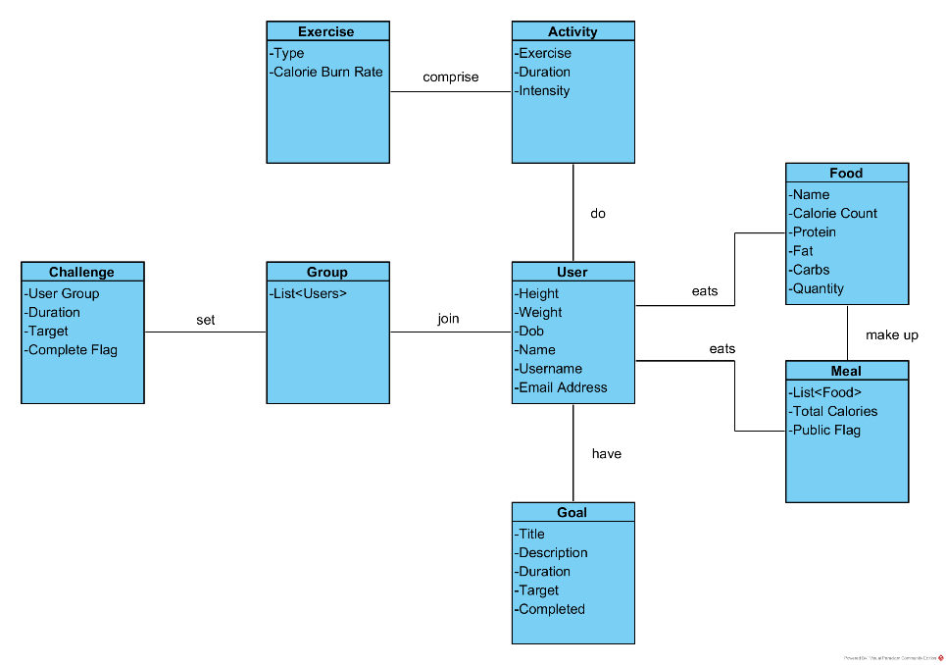This led to our initial class diagram:

# 4. Object Oriented Design (OOD)

We then expanded the initial class diagram design to produce our class diagram with greater detail:

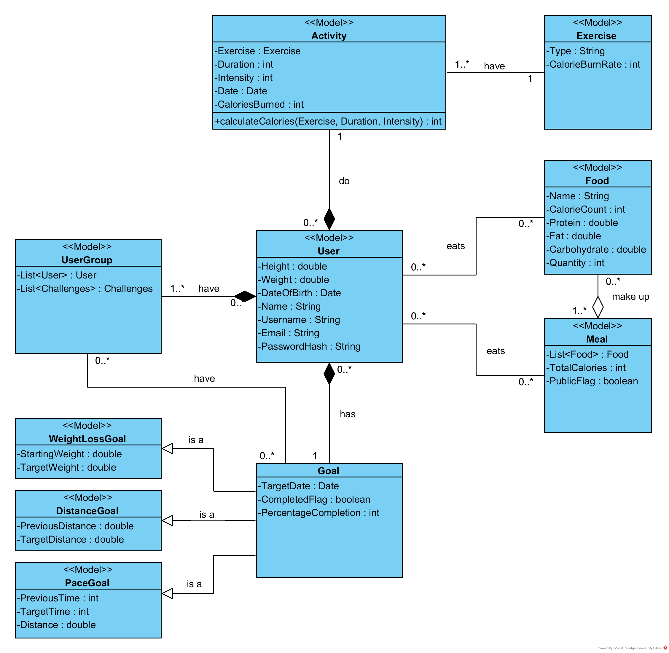

This class diagram was then used to make up the model part of our model view controller (MVC) diagram. We added in controllers for each of the classes as well as controllers to interface with important elements (such as the database):

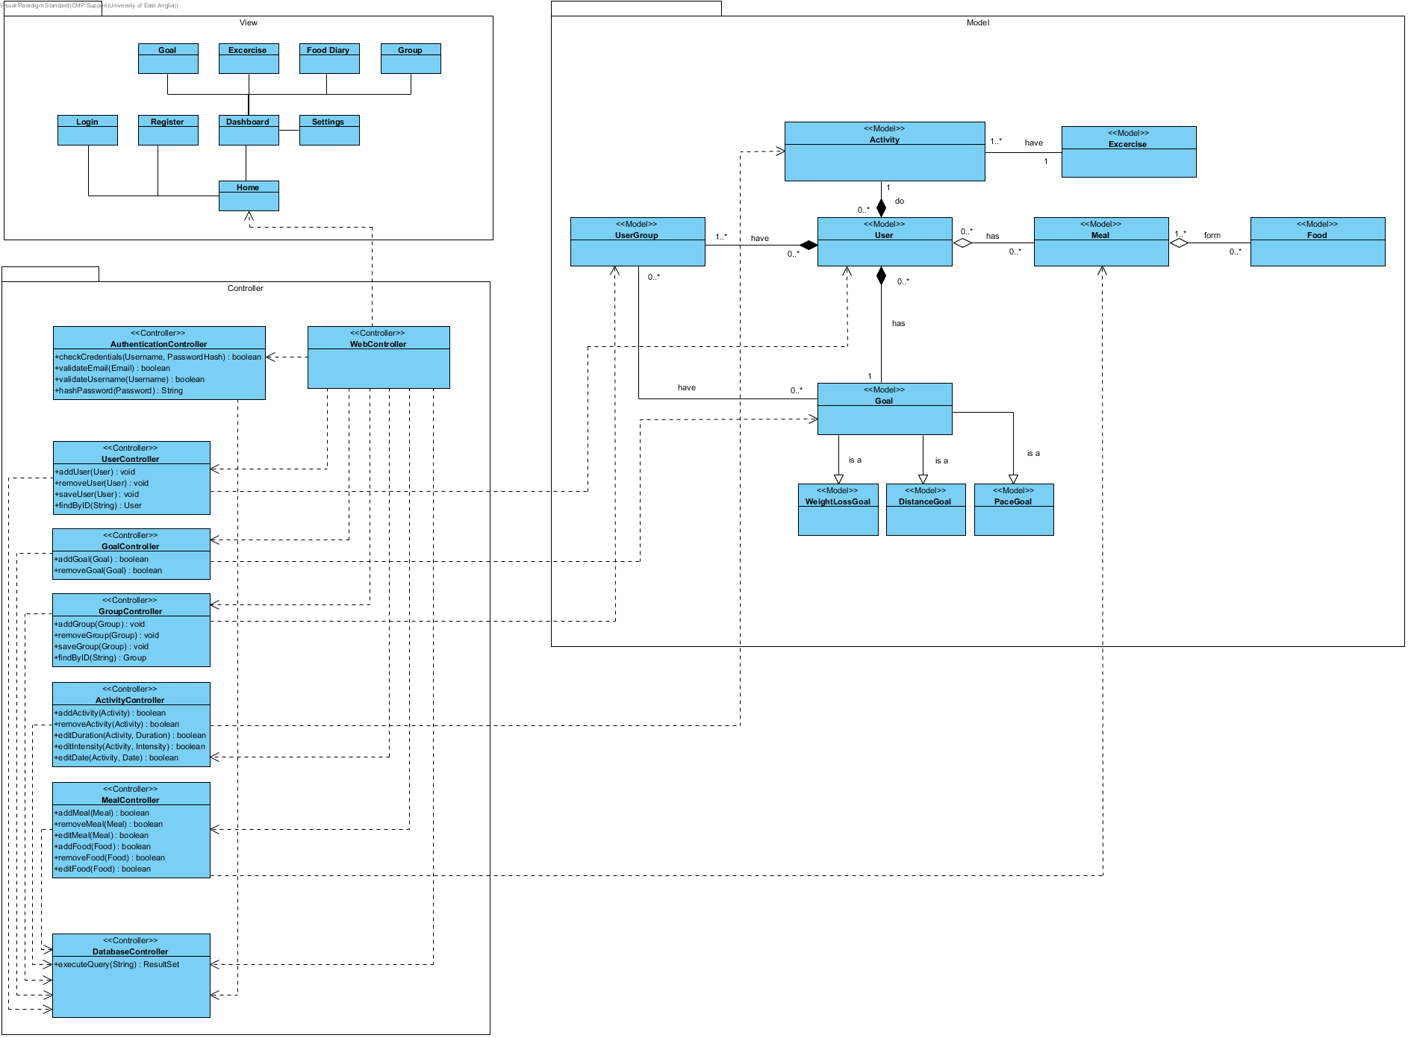

# 5. Initial Implementation

|  |  |
| --- | --- |
| Language | Java |
| IDE | JetBrains IntelliJ Idea |
| Platform | Web |
| Application |  |
| Additional Technologies | JSP, JDBC, PostgreSQL, Tomcat, Bootstrap, Javascript |

The main part of our initial implementation is the ability for users to register an account, sign in an view the welcome dashboard. This demonstrates the persistence of the user class to be stored on our database, authenticating a user’s credentials (including hashing their password for security) and providing the backbone for user profiles. User registration is part A of the specification and underlies most of the other requirements as it allows us to serve user specific content.

The classes UserController and AuthenticationController both contain full Junit test class to ensure they are functioning as expected.